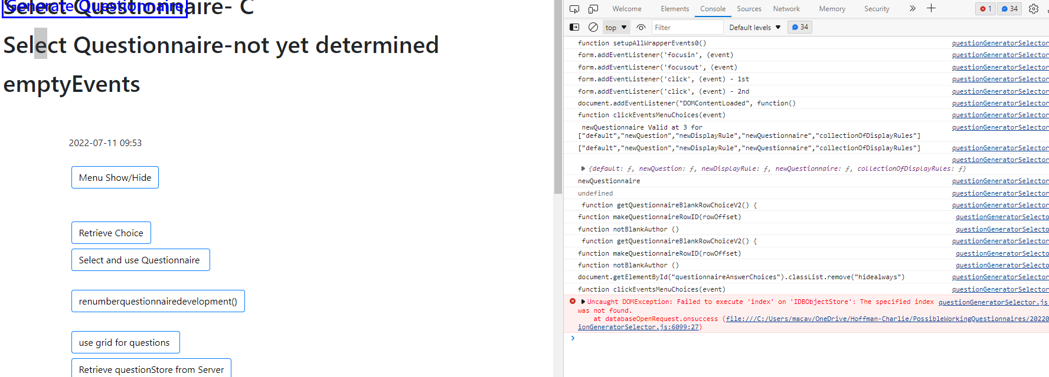1) looks like lots of console entries
From C:\Users\macav\OneDrive\Hoffman-Charlie\PossibleWorkingQuestionnaires\20201013

2) Look also at :
C:\Users\macav\OneDrive\Hoffman-Charlie\PossibleWorkingQuestionnaires\20220729

